Database design

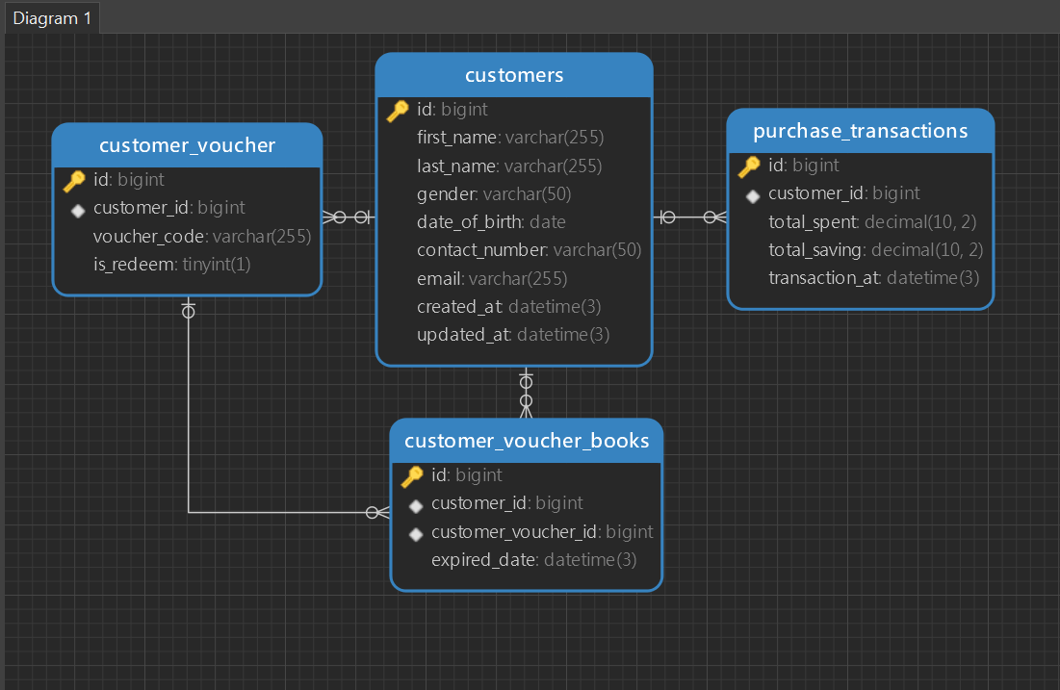

CONFIG

Database = Setup database connection

initData = for migration data seeder,if first initial you have value true,if not you have false.

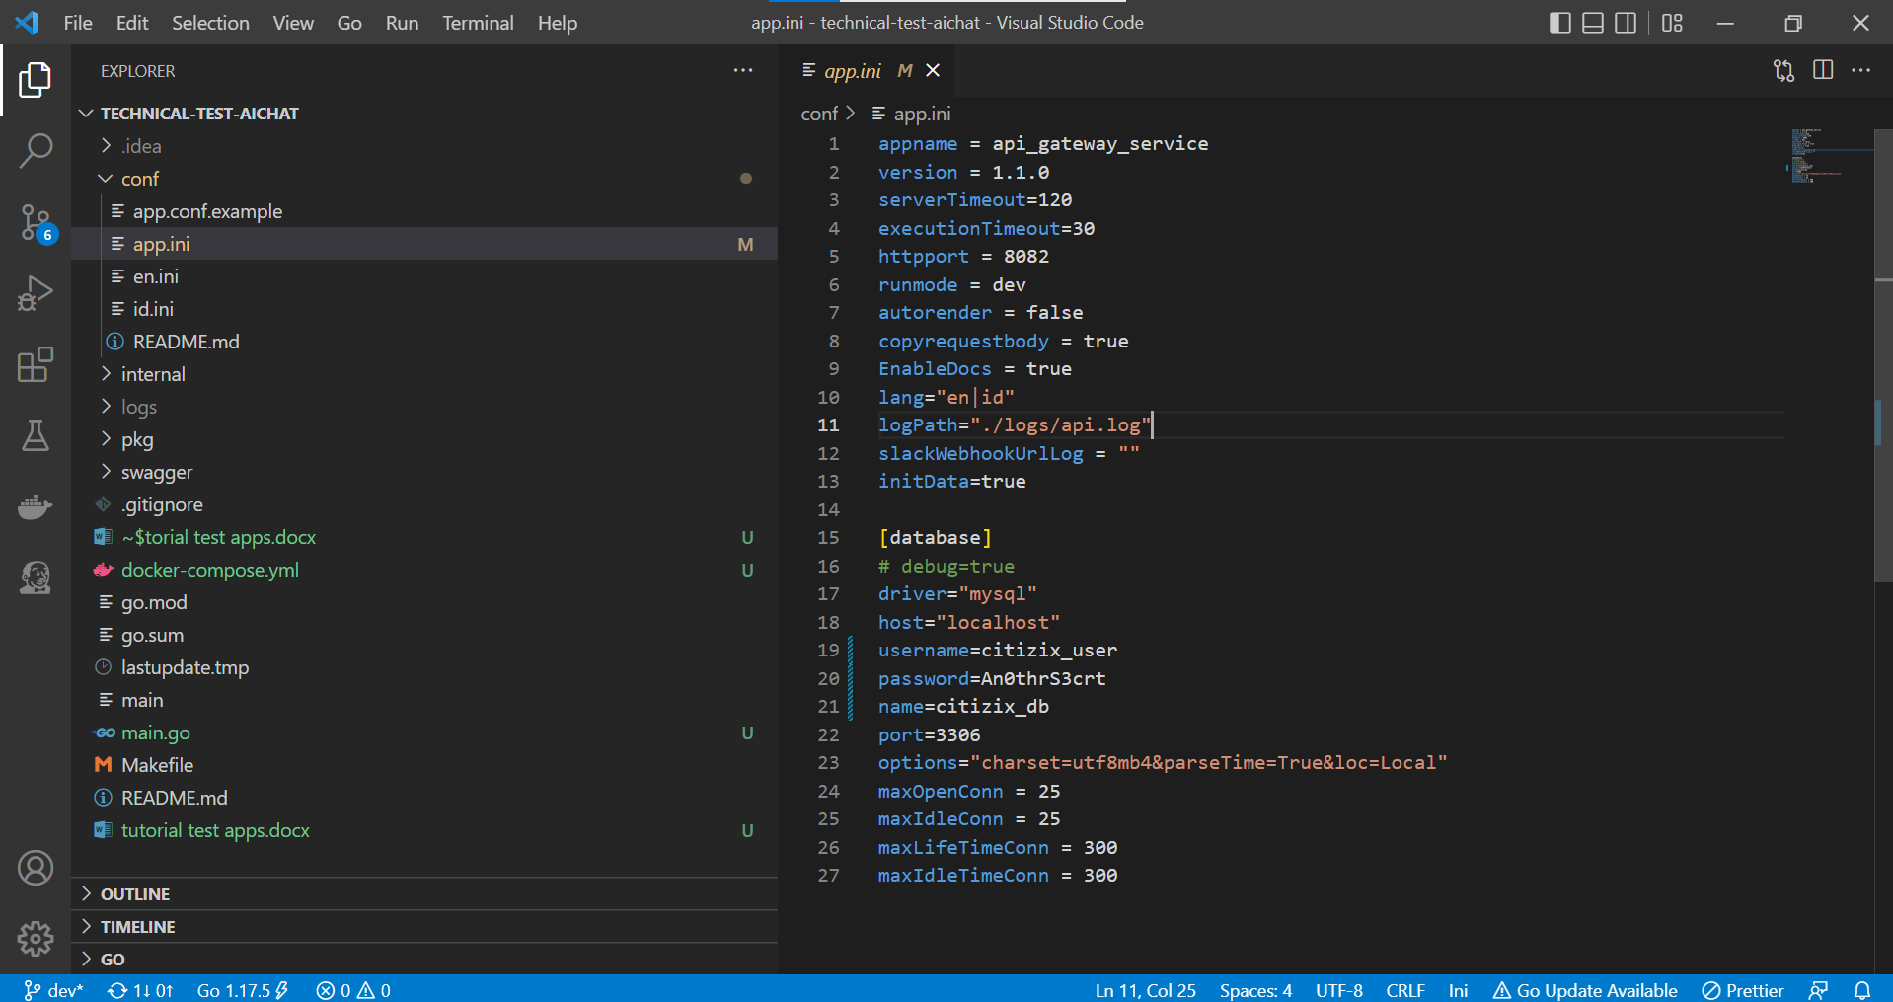

TESTING

For Positif case

* You must use customer eligibility requirement :

1. Customer must have atleast 3 purchase_transaction with transaction_at at 30 days latest
2. Customer must have atleast minimal total spent with all summary purchase_transaction with 100,
3. Customer not yet get voucher (customer not yet available customer_voucher_books and customer_voucher)

for example I use customer id = 2

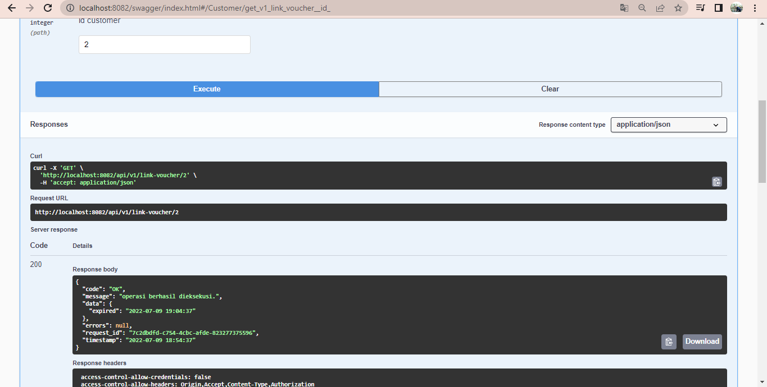

* Then verify image (validation with duration get link to verify image timeout 10 minutes with expired),you must upload file with correctly ,for fake validation image you can use image name use any text “face” and image size more than 50kb ,for example I use file image name “profile_face” with image size 117kb,and use customer id = 2

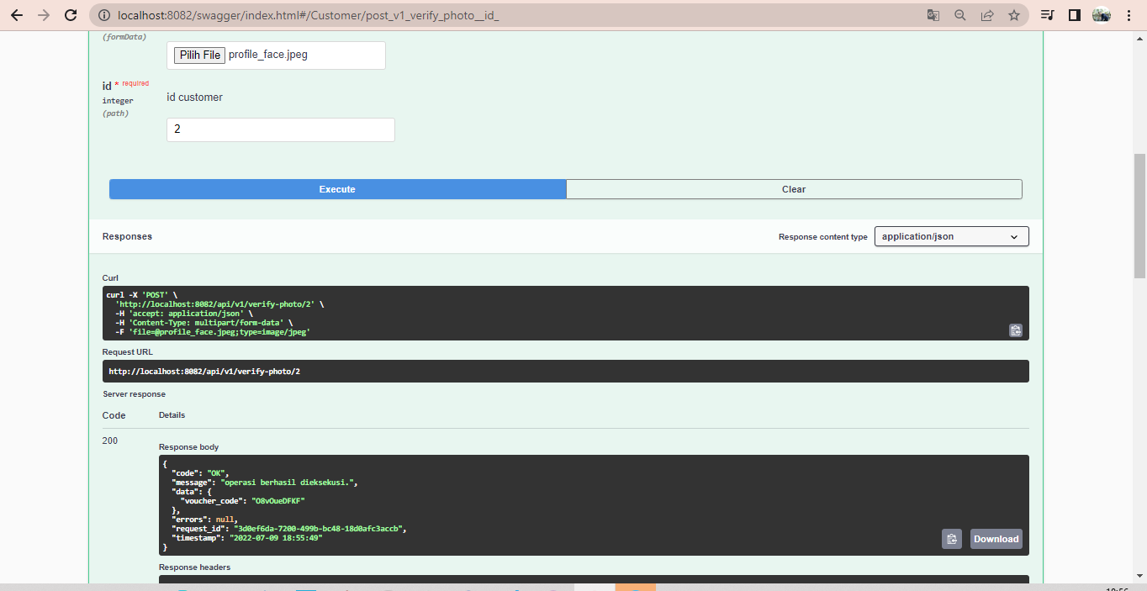

For negative case

* Customer not complete 3 purchase transaction last 30 days ,can you use Id customer = 10

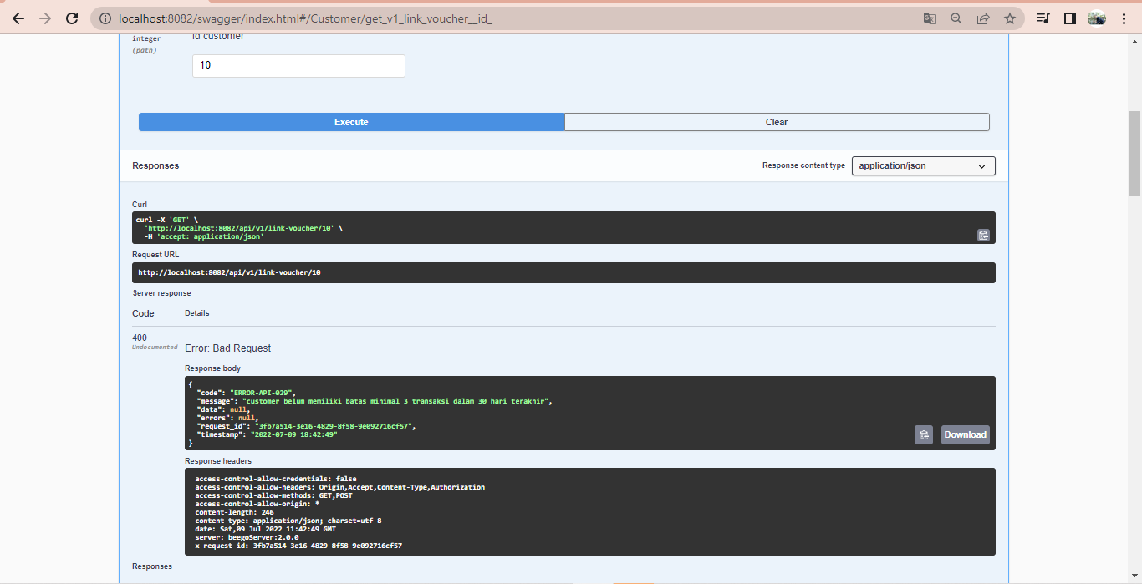

* Customer not equal all transaction summary more than $100,can you use id customer = 11

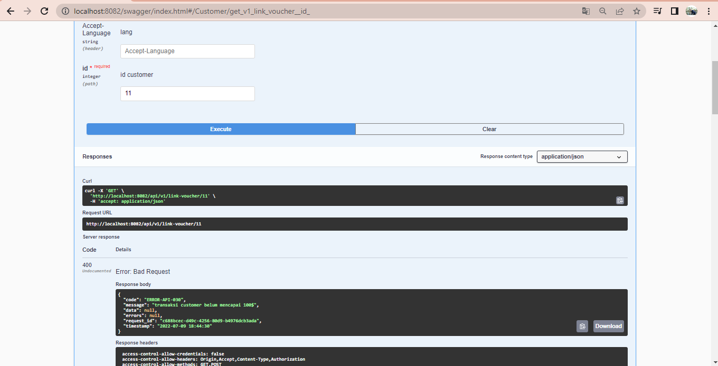

* Customer Already redeem voucher cash,and just only one voucher for one customer ,can you use id customer example = 1

First you finishing get voucher

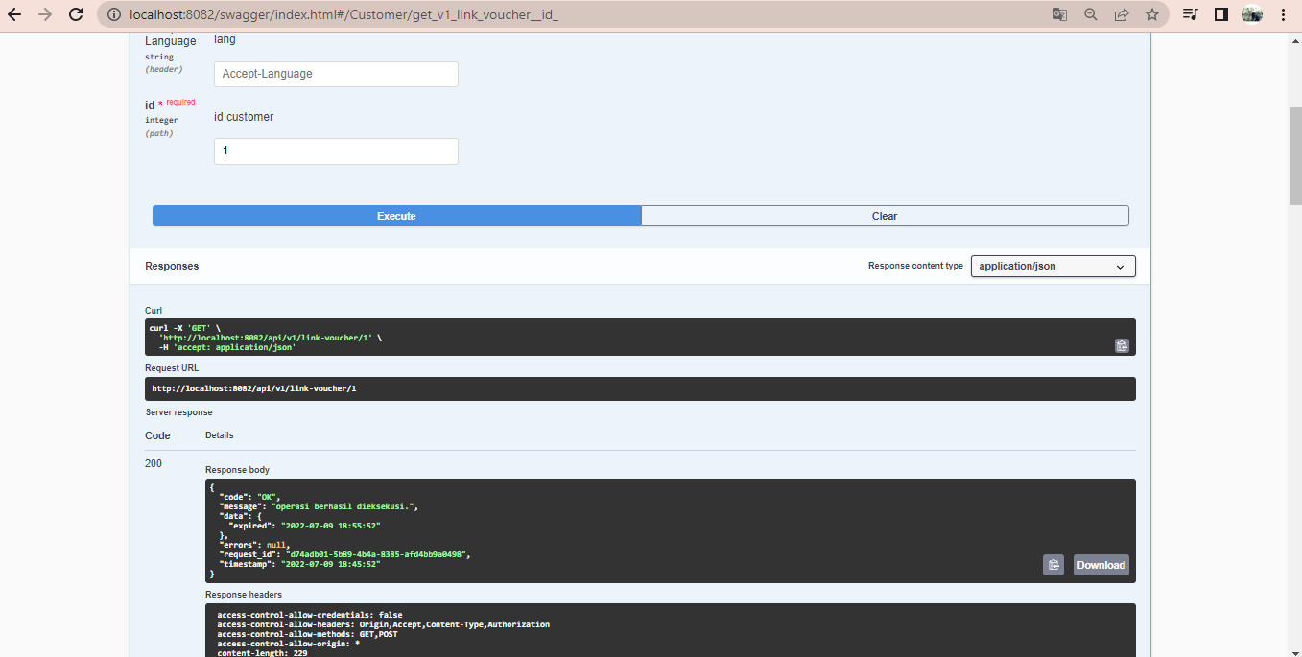

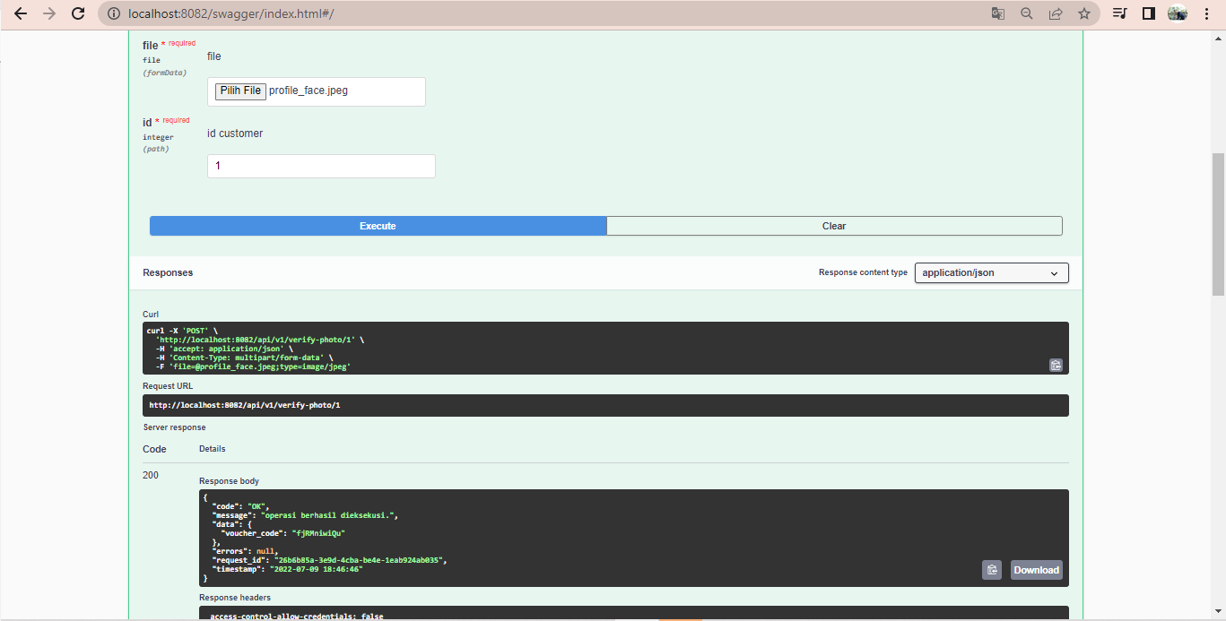

And if you request again ,you will detect validation you already get voucher

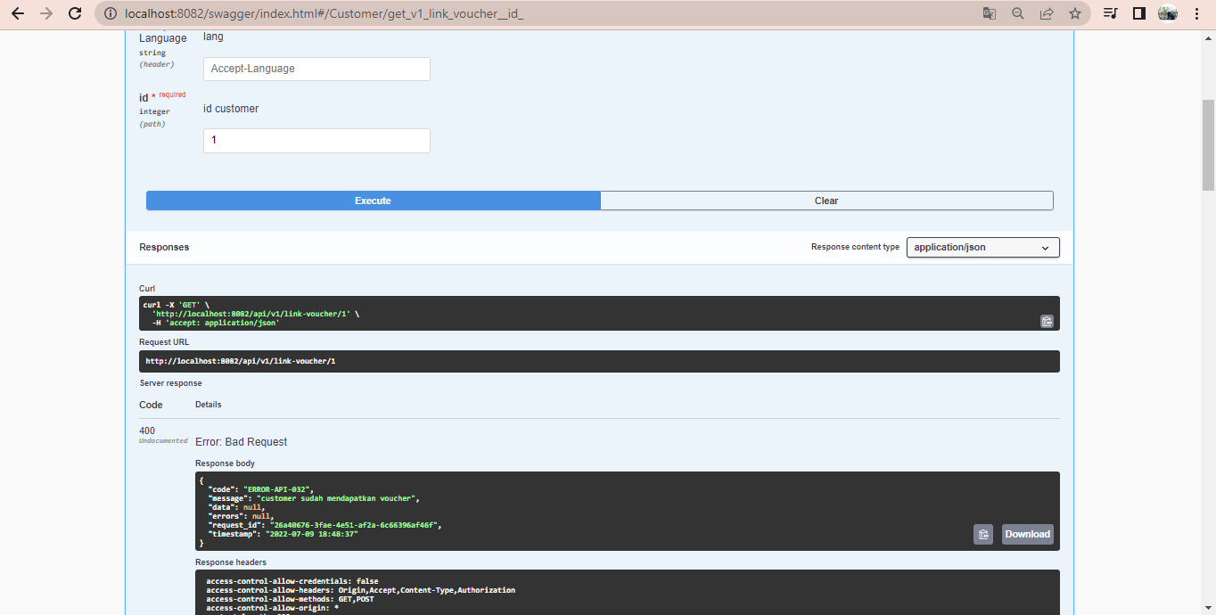

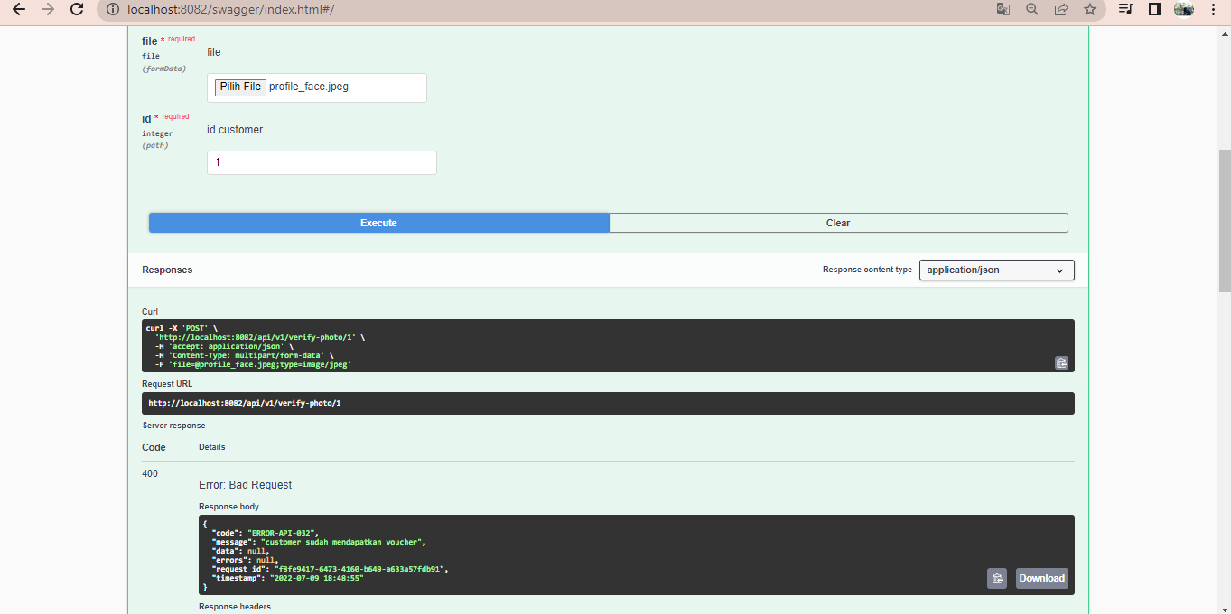

* Vouchers have run out

